PRESS RELEASE – For immediate release
Milano, March 7th 2017

wEating consciously at Fuorisalone – Din - Design In
DIN-DESIGN IN 2017

#din2017 #wEating2017
What we know about Fuorisalone is that many areas of Milan turn into real museums for designers coming from all over the world, visited by crowds of curious people, people passionate about design and people working in the design sector. Between an industrial recovery and the other it’s possible to relax eating a sandwich or drinking a coffee among the thousands of businesses that every year take part in the most visited exhibition of the city.
What we discover this year is that this year Din - Design In 2017 present the brand new edition of wEating 2017, where the common concept of food truck, used millions of time, now rises back from its ashes, creating a new hybrid: the food truck, which nor design and neither simple street food.
In the strategic location of via Massimiano 6 / via Sbodio 9, Din - Design In have a new and wider space for giving birth to wEating 2017. For the first time ever a selection of trucks are no more representing simple bridges between the exhibitions, and finally gain their deserved position as a real event in the event!
This first edition is the starting point of a renovated connection between food and design that aims to give food a significant space. This i show wEating is developed, as a real event like Fuorisalone, loved and followed by a heterogeneous audience, lover of good food and always seeking for food-tasting places around the city.
The event takes place in the spaces next to the Din - Design In location, prepared like a real refreshment zone with tables, chairs and design furniture. The trucks propose an offer connected to the surrounding they are in. Among the offers: ApeBedda, spokesperson of sicilian street food, and that has Pane Cunzatu had its forte. This product was born from the habits of the sicilian community that when in crises make a virtue out of a necessity: without any rich filling the bread was matched with low cost food. The recipe evolved and is now offered with richer and more sophisticated ingredients. From Sicily Marchese – Cannoli on wheels as well, that with his cart recalls the colors and the lines of the typical sicilians carts. With a patented refrigerating system that allows the ricotta to always be at its ideal temperature, he grants the client a always fresh and quality food.

Fuorisalone 2017 gains the colors and the tastes of Southern Italy: not only Sicily but also Puglia will be well represented. Thanks to Aperia we’ll discover the Salento’s taste, where street food is part of the tradition but also of nowadays daily life. The concept of that of spreading the food traditions thanks to a vehicle which is the symbol of Southern Italy: the Ape, that takes the smell, the taste and the colors of Puglia from city to city. La Puccia, with the typical salentino sandwich , soft inside and crispy outside. With its natural rising process, with drum wheat semolina, Extravirgin olive oil and its baking in the wood oven and its handmade fillings. Everything accompanied with the fine and slightly bitter beers and the unmissable wine from Salento.

While Southern Italy propose a rich and tasty offer, Northern Italy fight back with other great products. Following the trends Din - Design In selected a highly loved product: beer. For beer lovers Baladin offers a great variety of this product, with selected features aimed at the experts. Rivers of beer will then flow at the event in Lambrate, thanks to Beer Bike Baladin, that with its truck will give Milan the handmade beer produced by the famous Turin company.

In wEating also Brianza che nutre, a consortium of excellences, that went for the union form in order to properly represent the Brianza area, unique and variegated for the creations of an integrated system and for the organization of events that represent the local features. And if Ristorante Giorgione’s with the brand DAL PARMIGIANO gourmet street food has a whole parmesan menu, COOL Gelateria Naturale bases its concept on the respect for the people and the environment, whose ice-cream production follows the seasons. Apart from selecting high quality, and when possible bio and km. 0 ingredients, COOL uses bio and recycled materials both for the lab and for the shops. The electricity comes from renewable sources and the recycling is a significant part in their waste sorting process. No artificial ingredients, food colouring and chemicals are use.

Some European influence with Las Bravas that offers a food experience with Spanish tastes, taking a corner of Spain to Milan with a blue towing shaped as a Citroen Hy, a real tapas bar on wheels.

Common denominator is the passion for taste, the love the land and its products, but mainly the attention for the shape, the container that encloses the fruits of such hard work. Din - Design In wants these excellences to be its excellence, to offer its audience an experience full of emotions and amusement, that serves not only as a support but that also complete the exhibition experience.

www.weating.com

Din - Design In is an initiative realized by Promotedesign.it. Below, all the projects developed by Promotedesign.it.:
Design For, a book/catalogue with the best design-concepts carefully chosen by Promotedesign.it; a really useful tool for all the producer-companies that can select the best ideas from international designers.
Din - Design In, an expositive event created to give the chance to self-produced-designers to exhibit their creations to an international audience and having the possibility of a better spreading of their concepts.
Treneed.com, an e-commerce channel dedicated to all the people who loves or creates design and through the website they can make purchasing and selling products.

PROMOTEDESIGN. Since 2010 Promotedesign.it has been promoting design and creativity through a web platform connecting a big collective of designers and architects. Through the portal all registered users can create a professional profile from which they are able to manage personal information, contacts, pictures of products, concept, and developing projects, descriptions and biographies. The system has been conceived to get in touch all the actors in the sector, designers, companies, prototyping labs, photographers, machining workshops, press offices and communication to update and implement a network continuously changing. It is an instrument and an occasion to build new collaborations among different realities. Moreover Promotedesign.it offers disclosure on news, events, training and contests by giving space to a notice board, videos, legal area where discussing useful subjects for professionals in the sector . www.promotedesign.it

PRESS INFORMATION
Press office Promotedesign.it
Phone number: 02.36.58.02.08
Email: press@promotedesign.it

Press kit containing press release, company profile, low and high resolution images are available to the following link:: press kit

INFORMATION AND CONTACTS FOR THE PUBLIC
Din – Design In
From April 4th to April 9th 2017
Via Massimiano 6 / via Sbodio 9 (Zona Lambrate) Hour: everyday from 10 am to 8 pm
Wednesday the 5th until midnight
Free entry

Website: promotedesign.it
Facebook: facebook.com/Promotedesign
Twitter: @Promote_design
YouTube: youtube.com/user/PromoteDesign Instagram: instagram.com/promotedesign.it Pinterest: pinterest.com/promodesign

Hashtag: #din2017 #wEating2017

In Media Partnership with:

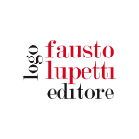 | 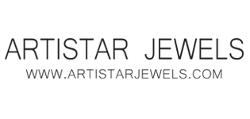 | 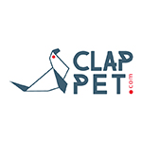
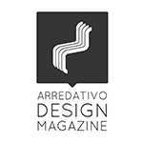 | 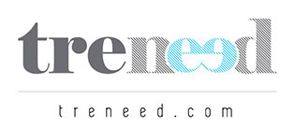 | 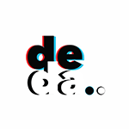
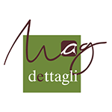 | 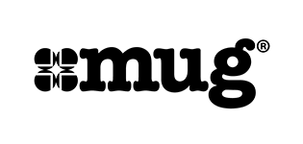
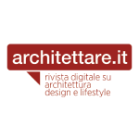 | 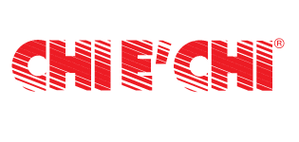 | 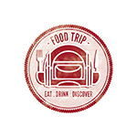
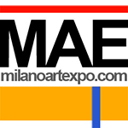 | 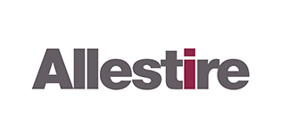 | 